ECI Organiser account: Procedure to create and configure your EU Login account to launch and manage an initiative

1. Context
In order to launch a European Citizens’ Initiative, your first step is to create an EU login account (if you do not have one yet). This account is created with your personal email address and helps you to access the ECI organiser account module where you can manage your initiative.
To strengthen the security, the authentication process is now based on a two-factor authentication, requiring an extra step after the password authentication. This process requires that you associate your mobile phone number to your EU login account.
The procedure on how to create your EU login account and how to associate your EU login account and your mobile phone number is described hereafter.

2. Creating an EU login account
After you have decided to create an Organiser account by clicking on the ‘Organiser account’ button ( https://register.eci.ec.europa.eu/organisers )
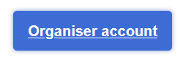
you are redirected to the EU login page:
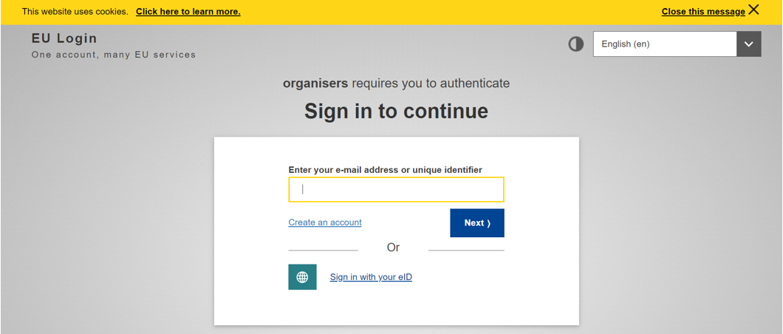

If you do not have an account, please click on the Create an account link (in case you have one, go to step 3)

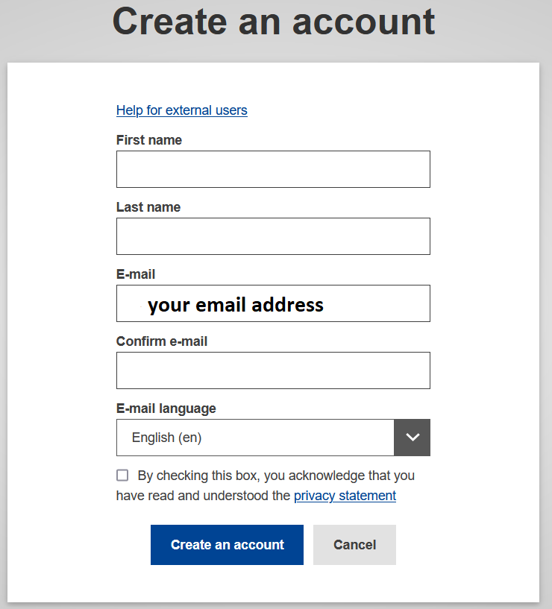
After you filled all the fields, checked the privacy statement box and clicked on “Create an account” button, the request should be processing.
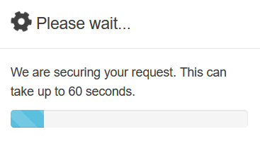

When this step is finished, you should receive this message:
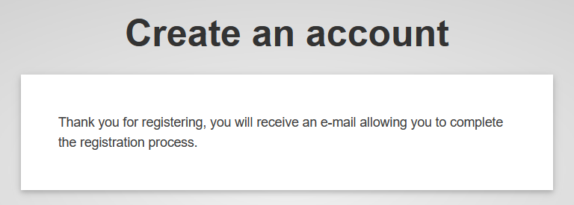
Go to your email account, open the email received and click on the link, to add password.
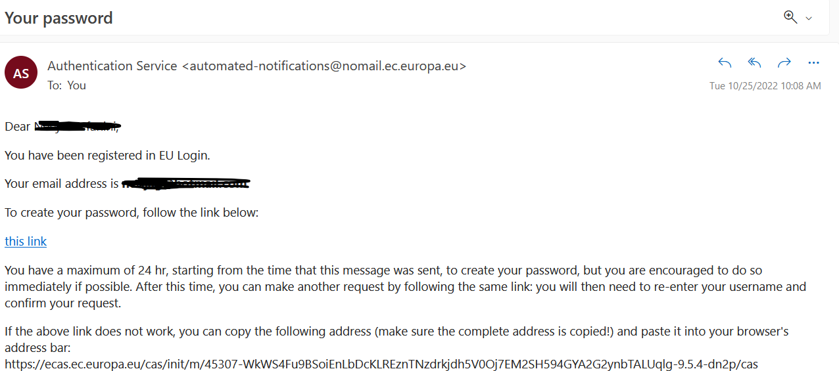

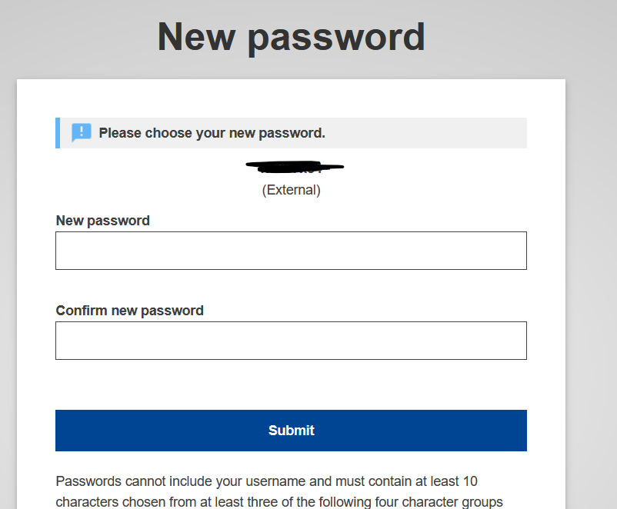

3. Associating your mobile phone number to your EU login account
Once your EU login account has been created, you will need to associate your mobile phone number to it to go through the two-factor authentication.
The procedure on how to associate a mobile phone number to your EU login account is described (in English) in the EU login tutorial accessible on the following page: https://webgate.ec.europa.eu/cas/manuals/EU_Login_Tutorial.pdf
To start, please look at the following section from the EU login tutorial:
  - page 24: Register a mobile phone number for receiving verification SMS.
Note that if you completed the registration of your mobile phone number, it should already be sufficient to authenticate using the method Mobile Phone + SMS
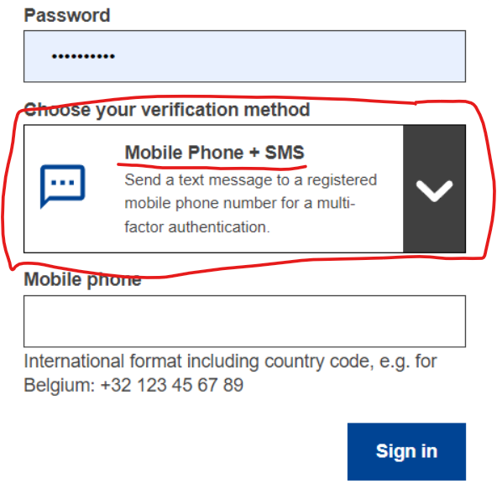
However, if you wish to use other authentication methods, faster than the SMS, please go to the section ’Install and initialise the EU Login Mobile App’:

  - page 20: Install and initialise the EU Login Mobile App
You will then be able to log in either using the push notification or the EU login Mobile App QR Code
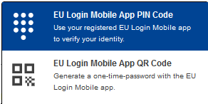
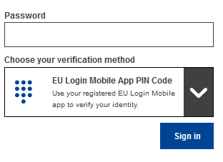
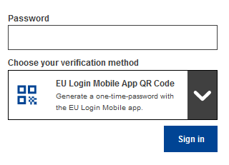

Link to the EU Login account configuration
At any moment you can click on this link to connect to your EU login account: https://webgate.ec.europa.eu/cas/userdata/myAccount.cgi
The EU login account tutorial (in English) is available here: https://webgate.ec.europa.eu/cas/manuals/EU_Login_Tutorial.pdf

