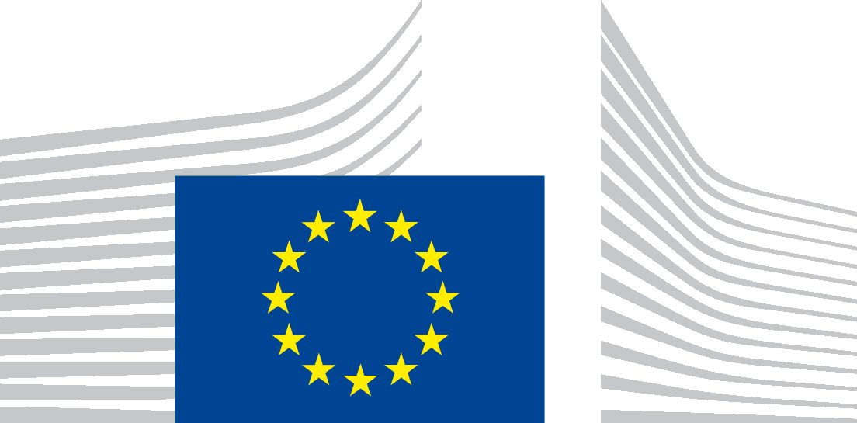 | EUROPEAN COMMISSION  SECRETARIAT-GENERAL  Directorate A - Strategy, Better Regulation & Corporate Governance  SG.A.1 - Policy Priorities & Work Programme
Authorisation for the taking of
photograph(s) of a minor | film(s) of a minor
Subject of the photograph/film for the ‘ImagineEU’ school competition: [Briefly describe the topic of the picture/film, so that it can be easily identified] ________________________________________________________
______________________________________________________________________________________________
______________________________________________________________________________________________
Date of the photograph/film: _______________________ Location(s): __________________________________

I, ____________________________________________________, born on ________ and residing at: ________________________________________________________________________________________
declare that I willingly agree to be photographed and filmed for the purposes of the ‘ImagineEU’ school competition organised by the European Commission’s Secretariat-General, Unit A.1 - Policy Priorities & Work Programme.
I hereby agree to the Competition Rules and Privacy Statement for the school video competition ‘ImagineEU’.
I authorise the European Commission (EC):
- to process my image and video for the purposes of the ‘ImagineEU’ school competition, to use without restriction the photographs and/or films bearing my image as described in the Competition Rules and Privacy Statement in all types of publications, in any form of audiovisual broadcasting or communication via the Internet;
- to include and archive these photographs and/or films in the European Union’s online databases, accessible to the public free of charge. Third parties with authorised access to these databases may use the said photographs and/or films in compliance with the EC's Decision on re-use of Commission documents (2011/833/EU) for information or education purposes only;
to illustrate or promote the activities or projects of the European institutions and the European Union as defined in DPR-EC-09286.

I hereby give my consent to the processing of my personal data to the extent necessary for the achievement of the purposes mentioned above, in accordance with the Privacy Statement. The EC guarantees that personal data relating to me are processed in accordance with Regulation (EU) 2018/1725. Data may be archived by the EC.
I understand that, as data subject:
- I can withdraw my consent to the processing at any time. The withdrawal will not affect the lawfulness of the processing carried out before I have withdrawn the consent.
- I have the rights set out in the Privacy Statement.
To withdraw consent or exercise these rights, please contact the
EC at: SG-ECI-INFO@ec.europa.eu.
This authorisation shall apply worldwide and for as long as my image/film is subject to legal protection. It can be withdrawn by informing the EC at the address mentioned above.

Signature of the student preceded by the words ‘read and approved’  Date: | Signature(s) of the parent(s)/legal representative(s), preceded by the words ‘read and approved’  Date:  Name and Surname:

